

**Assignment :**

**Submitted by: Hira sohail**

**Subject : AICT**

**Roll no** **: 76**

**Submitted to: MS ABQA**

STUDENT INFORMATION FORM

 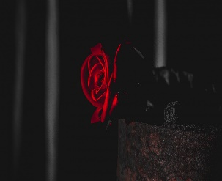

Session 2023 / 1 semester

Department of Computer Science and Engineering

University of Engineering and Technology, Lahore.

1. NAME : HIRA SOHAIL

Tick one of the following

1. GENDER : MALE ⬜ FEMALE 🗹
2. DATE OF BIRTH : 03/08/2005
3. RESIDENCE : 17 – A ,Ghulam Hussain park shad bagh , Lahore.
4. CITY : Lahore
5. MOBILE : 03244341551
6. EMAIL : [hirasohail999@gmail.com](mailto:hirasohail999@gmail.com)
7. HOBBIES : watching mobile
8. FAVORITE MOVIE : Elemental